**A Study on Mobile Banking App Usage  
in Sri Lanka**

A.A.H.W.S. Herath

Department of Computer Science & Engineering

Faculty of Engineering

University of Moratuwa

Email: wikasitha.20@cse.mrt.ac.lk

***Abstract---*** **Mobile banking apps are the raising trend in between Sri Lankans since it makes day today life more easy than past and even bankers also try to optimize their mobile banking facility among general public. Simply we can define mobile banking as “type of execution of financial services in the course of which within an electronic procedure – the customer uses mobile communication techniques join with mobile devices”. Moreover, it is defined as “a channel whereby the customer interacts with a bank via a mobile device, such as a mobile phone or personal digital assistant” Today, mobile banking apps are mostly used by people for make their bill payments in online. Also, they trust this service to transfer money from one account to other since it saves their time and money.** **Even still all of people not familiar with mobile banking apps, but most of users who are using this service are highly satisfied with the recent developments in the banking services in Sri Lanka and they are willing to recommend this for new ones. Now a day’s customers expect more facilities via mobile banking. Here I have made this study to identify the behaviors of mobile banking app usage among Sri Lanka community. This study will help for bankers to optimize their next business plans and they must update the mobile banking facilities which would satisfy the customers more and more.**

***Keywords. Mobile banking, apps, bankers***

1. Introduction

Mobile banking is becoming increasingly common in Sri Lanka and it has proven to be the fastest and convenience way of accessing the banking services worldwide. It reduces the need to go to a physical bank to withdraw cash and make payments. Mobile banking provides easy and instant access to banking transaction anywhere and in 24 hours a day. This technology has increased in developed countries compared to developing countries. Now the, technology has opened new markets, new products, new services and efficient delivery channels for the banking industry. Specifically, banking industry has undergone radical changes because of the breath-taking developments in this technological revolution. Banks have changed from paper-based banking solutions provider to the latest of the technologies like online-banking, mobile-banking, etc. Also, to cater to the ever-increasing consumer expectations and demand, the banking industry has these technologies to offer banking services at the convenience and comfort of its customers.

New business models, processes and revolutionized distribution channels are the result of technical advances in the banking industry. Mobile commerce is one of natural successor to electronic Commerce. Mobile banking is a transformation that is driven by the world's one of the fastest growing sectors mobile communication technology. Mobile banking is described as an interconnection in which a customer is connected to a bank via a mobile device such as cell phone, smartphone or personal digital assistant (PDA) [1]. Mobile banking can also be considered as the convergence of mobile technology and financial services [2]. M-banking is a subset of super set banking as it allows everyone easy access to their banking activities via mobile handsets.

All over the world bankers have been effectively deploying information technology as an innovative resource to achieve speed, efficiency, cost reduction, customer service and competitive advantage. Technology enabled delivery channels and products provide value to customers providing them with anywhere, anytime, anyway banking to customers Developing countries like Sri Lanka, banks have realized need to remain competitive through provision of quality services to their customers. To achieve this, they need to have the latest technology in place such as mobile banking which gives mobile platform that offers a convenient method for managing money without handling cash. “Financial institutions, which have had difficulty providing profitable services through traditional channels to poor clients, see m-banking as a form of branchless banking”[3]. This lowers the costs of serving low-income customers.

1. Motivation

In this paper I have focused on how demographic information affects mobile banking app usage among the Sri Lankan community. To perform this study, I have created a survey which includes 20 questions. All questions have been created using both Sinhala and English language for convenience. Basically, I shared my questionnaire via online platform like WhatsApp and Facebook groups for data collection purpose. Finally, 171 different users from different locations in Sri Lanka had responded to my questionnaire. Here I have designed many diagrams and graphs to highlight what factors cause for mobile banking app usage in Sri Lanka.

At present Sri Lanka, there are many banks in both government and private sector. Both groups are introducing their latest mobile banking apps for the community. Below tables indicate all the current banks which provide banking facility in Sri Lanka.

Table 1:Licensed Commercial banks in Sri Lanka

|  |  |
| --- | --- |
| Licensed Commercial banks | |
| Amana Bank | ICICI Bank Ltd |
| Bank of Ceylon | National development Bank PLC |
| Bank of China Limited | Nations Trust Bank PLC |
| Cargills Bank Ltd | Pan Asia Banking Corporation PLC |
| Citibank N.A. | People's Bank |
| Commercial Bank of Ceylon PLC | Sampath Bank PLC |
| Deutsche Bank AG | Seylan Bank PLC |
| DFCC Bank PLC | Standard Chartered Bank |
| Hatton National Bank PLC | The Hong Kong and Shanghai Banking Corporation Ltd (HSBC) |

Table 2:Licensed Specialized Banks in Sri Lanka

|  |
| --- |
| Licensed Specialized Banks |
| Housing Development Finance Corporation Bank of Sri Lanka (HDFC) |
| National Savings Bank |
| Regional Development Bank (Pradheshiya Sanwardhana Bank) (RDB) |
| Sri Lanka Savings Bank Ltd (SLS Bank) |
| State Mortgage & Investment Bank (SMIB) |
| Sanasa Development Bank (SDB Bank &  U pay) |

Table 3: Most popular mobile banking apps in Sri Lanka

|  |  |
| --- | --- |
| Bank Name | Mobile App Name |
| Bank of Ceylon | BOC Smart Passbook,  Bank of Ceylon Mobile Banking,  BOC SmartPay |
| Commercial Bank of Ceylon PLC | Combank Digital,  ePassbook,  COMBANK ComBank Q Plus Consumer |
| Hatton National Bank PLC | SOLO by HNB/HNB Mobile Banking |
| National Development Bank PLC | NDB Neos |
| Nations Trust Bank PLC | FriMi  Nations Mobile Banking |
| People's Bank | People's Wave |
| Sampath Bank PLC | Sampath Bank Mobile App (Sampath Vishwa) |
| Seylan Bank PLC | SEYLAN Mobile Banking App |

Table3: shows most popular mobile banking apps which are currently used by Sri Lankan and among them FriMi banking app from NTB is the most popular mobile banking app in recent days since it provides many services with multiple options for users.

1. Data Processing

Data collection was conducted via google form and I have created my questionnaire in both Sinhala and English language and reached to users via online platform. Here this has focused only people who are using mobile banking apps. Data set consists 171 data records(rows) with 21 columns with timestamp.

Since I have included many options for users to select under relevant questions, there were many different options in one Colum, and I have re arranged them with alphanumeric values. Then it was easy to perform data analyzing part. Even it included 21 columns I removed unwanted columns like timestamp.

1. DESCRIPTIVE ANALYSIS

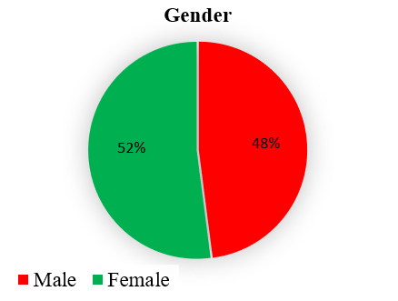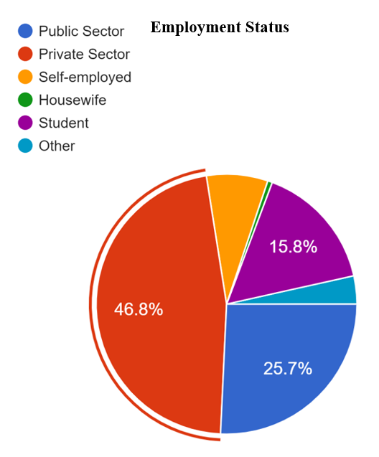It consists many user demographical questions and common questions based on banking apps. As per our data set, it is clear most of females are using mobile banking apps than male(figure1). As percentage it has taken 52% for females. And Figure 2: indicates the how age groups begave with banking app usage. Most of users (90.1%) from 19-30 age group are using mobile banking apps rather than other age groups.

Figure 1: Banking app usage vs Gender

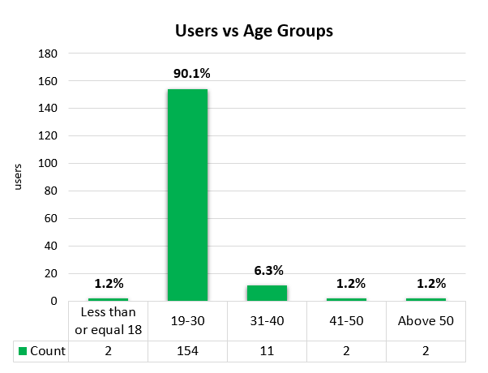

Figure 2: Users vs age groups

Furthermore, I paid my attention to consider users occupation and their educational qualification level and tried to find the relationships between those facts and mobile banking app usage. In later section I have described them clearly using stoical approaches. Figure 3 shows the respondent user’s occupation details and it shows most of users from private sector use mobile banking apps than Sri Lankan government sector people. As a percentage 15.8% students are using mobile banking and it is really good point that emphasize Sri Lankan young crowd is closing modern technologies and they can easily adopt with emerging technology and quick tactics since they are the people who are seeking new knowledge. Bankers should focus youth desires for next business plans to reach maximum user satisfaction of these products.

Figure 3: User occupation vs banking app usage

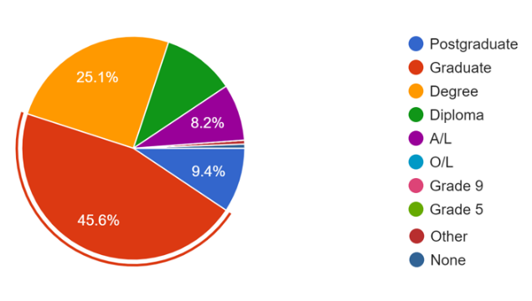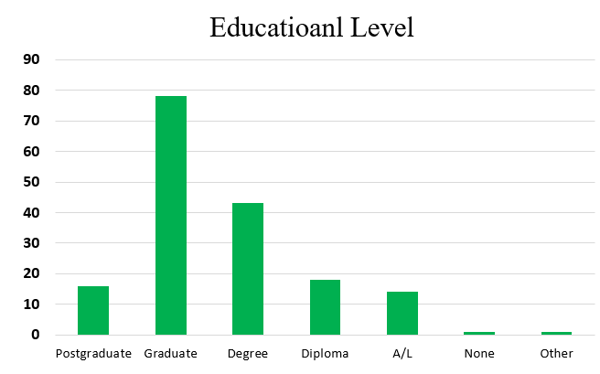As per the dataset the educational levels of users are indicated in figure 4 and 5, and it is clear most of graduate, undergraduate and postgraduate people use mobile banking facility than others.

Figure 5: Educational level and user percentage

Figure 4: Educational level vs banking app usage

In this data set majority of users are included in 19-30 age group and I have done further analysis focusing that group. Figure 6: shows most of users who use mobile banking app from 19-30 age group are using government banking apps for their day today activities and it seems most of them trust with government banks apps rather than private banking apps. At present there is big competitions between private banks and government banks by introducing new technology into their traditional banking systems and try to reach with high user satisfaction day by day.

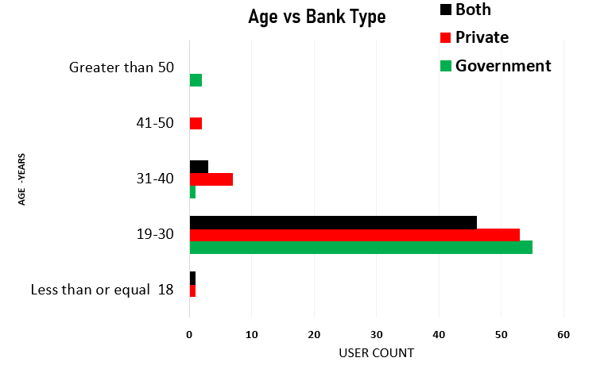

Figure 6: Age group vs mobile banking app usage

1. STATISTICAL ANALYSIS

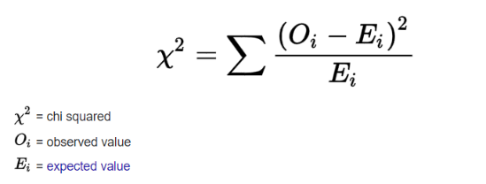Here a statistical approach has been used to identify if there any associations between any attributes which course for mobile banking app usage. Basically, I have used hypothesis testing and Chi-squared test testing to reach my goal. For this scenario I have selected many critical attributes to perform hypothesis testing. I have mentioned all the test details in this section. Figure 7 shows the equation of Chi-squared test.

Figure 7: Chi Squared formula

Association between respondent's opinion for safety of the mobile banking and their age group –01

**H0:** There is no significant association between age of the respondents and their opinion about if mobile banking services are safe or not.

**Ha:** There is a significant association between age of the respondents and their opinion about if mobile banking services are safe or not

Table 4: Observed frequency for association -01

|  |  |  |  |
| --- | --- | --- | --- |
| **Observed Frequencies** | | | |
| Age | Yes | No | Neutral |
| Less Than or Equal to 18 | 1 | 0 | 1 |
| 19 - 30 | 99 | 3 | 52 |
| 31 - 40 | 7 | 0 | 4 |
| 41 - 50 | 0 | 0 | 2 |
| Above 50 | 1 | 0 | 1 |

Table 5: Expected frequency for association -01

|  |  |  |  |
| --- | --- | --- | --- |
| **Expected Frequencies** | | | |
| Age | Yes | No | Neutral |
| Less Than or Equal to 18 | 1.263 | 0.035 | 0.702 |
| 19 - 30 | 95.368 | 2.649 | 52.982 |
| 31 - 40 | 6.947 | 0.193 | 3.859 |
| 41 - 50 | 1.263 | 0.035 | 0.702 |
| Above 50 | 1.263 | 0.035 | 0.702 |
| P value = 0.805 | Significant value =0.05 | | |

Here, P value (0.805) > 0.05, So Results are not statically significant.

Findings: **Ha** hypothesis is rejected, and the null hypothesis is accepted. There is no significant association between age of the respondents and their opinion about mobile banking services are safe or not. Next association is mentioned below.

Association between gender of the respondents and their recommendation of mobile banking. –02

**H0:** There is no significant association between gender of the respondents and their recommendation of mobile banking

**Ha:** There is a significant association between gender of the respondents and their recommendation of mobile banking

Note: in below tables “yes” = They recommend banking app to others, “No” = not recommended

Table 6: Observed frequency for association -02

|  |  |  |  |
| --- | --- | --- | --- |
| **Observed Frequencies** | | | |
| Gender | Yes | No | Row Total |
| Male | 80 | 2 | 82 |
| Female | 88 | 1 | 89 |
| Colum Total | 168 | 3 | 171 |

Table 7: Expected frequency for association -02

|  |  |  |  |
| --- | --- | --- | --- |
| **Expected Frequencies** | | | |
| Gender | Yes | No | Row Total |
| Male | 80.561 | 1.439 | 82 |
| Female | 87.439 | 1.561 | 89 |
| Colum Total | 168 | 3 | 171 |
| P value = 0.513 | Significant value =0.05 | | |

Here, P value > 0.05, Results are not statically significant.

Findings: **Ha** hypothesis is rejected, and the null hypothesis is accepted since P value is greater than 0.05. There is no significant association between gender of the respondents and their recommendation of mobile banking apps.

Association between user satisfaction for bill payments via banking app and their age group –03

**H0:** There is no significant association between age group of the respondents and their satisfaction for online bill payment via mobile banking services.   
  
**Ha:** There is a significant association between age group of the respondents and their satisfaction for online bill payment via mobile banking services.

I could identify majority of mobile banking app users use these apps to make online bill payments. In this data set 151 from 171 users use app for mainly make bill payments. Figure 8: shows the behavior of age vs user satisfaction for online bill payment option via mobile banking app.

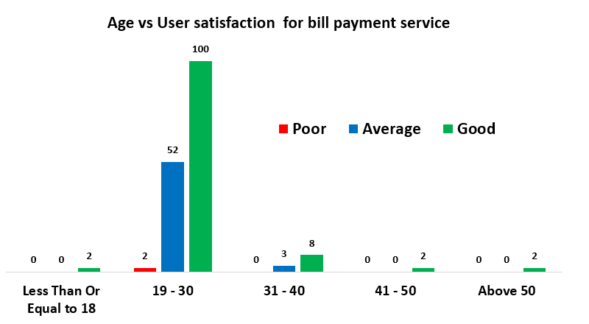

Figure 8: Age vs bill payment option

As per the Chi-squared test, it gave the P value =0.90 significant value =0.05, DF=8

Here, P value > 0.05, Results are not statically significant

Findings: **Ha** hypothesis is rejected, and the null hypothesis is accepted.

There is no significant association between age group of the respondents and their satisfaction for online bill payment via mobile banking app.

Next, I have mentioned how it behaves between user’s educational level and their recommendation of mobile banking apps in association -04

Association between educational qualification of the respondents and their recommendation about mobile banking service. –04

**H0:** There is no significant association between educational qualification of the respondents and their recommendation of mobile banking.

**Ha:** There is a significant association between educational qualification of the respondents and their recommendation of mobile banking.

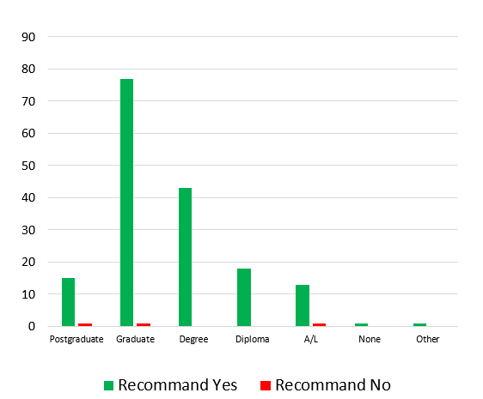

Figure 9: User educational level vs their recommendation of app

As per the figure 9:it says majority of users like to recommend banking app for others since they are satisfied with current services provided from bank via app.

According to the Chi-squared test, it says P value is 0. 4856.So significant value =0.05, DF=1

Here, P value > 0.05, then results are not statically significant.

Findings: **Ha** hypothesis is rejected, and the null hypothesis is accepted since P value is greater than 0.05.

There is no significant association between educational qualification of the respondents and their recommendation of mobile banking.

1. CONCLUSION

This Study for the usage of mobile banking apps has been conducted from 171 random users from different locations in Sri Lanka. This has shared via only WhatsApp and Facebook groups and data were collected within two weeks. As per this study, it indicates majority (90%) of the age (19-30) customers are using mobile banking apps. Also, it shows most of the graduated/postgraduate people use mobile banking apps. Furthermore, this says majority of private sector people use mobile banking apps than government sector. We can see majority of users from 19-30 age group trust government banks than private banks for mobile banking. And also Sri Lankan bankers should focus above mentioned chi-square test results for their next project plans since user satisfaction is the most important fact for the success of the bankers.

1. FUTURE WORK

This study will help to optimize the new ideas regarding for mobile banking apps and furthermore as the future works, I hope to perform this study with large number of users in Sri Lanka. Then we can get well balanced data set for our next studies and it will be very effective resource to optimize new ideas and plans in mobile banking usage in Sri Lankan community.

1. ACKNOWLEDGEMENT

I would like to express my gratitude to my primary supervisor Dr. Uthayasanker Thayasivam for his great support and guidance to carry out this analytical study. I would also like to thank our friends and family and all who supported me and offered deep insight into the study.

REFERENCES

1] T. Laukkanen, V. Kiviniemi, V (2010) “The role of information in mobile banking resistance”. International Journal of Bank Marketing 28: 372-388

[2] N. Chung, S. Kwon (2009) “The effect of customers' mobile experience technical support on the intention to use mobile banking.” Cyber Psychology and Behavior 12: 539-543

[3] T. Yu, K. Fang (2009) “Measuring the post-adoption customer perception of mobile banking services” Cyber Psychology and Behavior 12: 33-35

[4] T. Laukkanen, M. Pasanen (2008) “Mobile banking innovators and early adopters: How they differ from other online users?” Journal of Financial Services Marketing 13: 86-94

[5] Y. Wang, H. Lin, P Luarn (2006) “Predicting consumer intention to use mobile service”. Information Systems Journal 16: 157-79.

[6] M. Mattila (2004) “Factors affecting the adoption of mobile banking services.” Journal of Internet Banking and Commerce.